**DAPP Proposal**

**Group Members**:

Ammar Nadeem 19L-0911 9A  
Abdul Rehman(Leader) 19L-1135 7A

DAPP Details:

**Title: To-Do List**

Description: Create a TODO list DApp where users can add items, prioritize them and delete them.

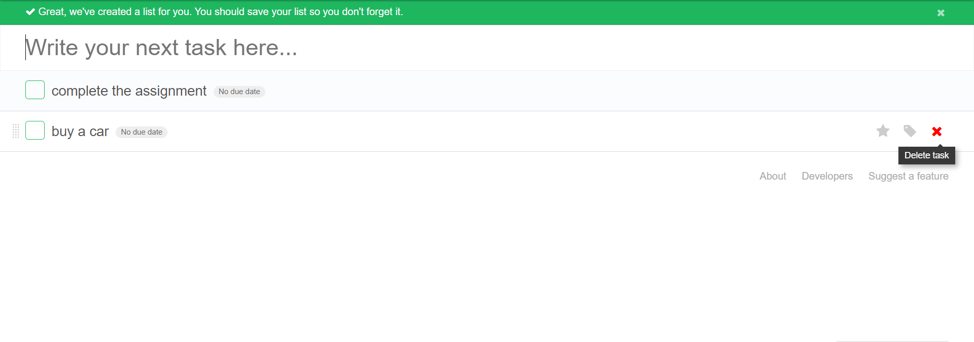

Distribution of work:

Ammar:

Create Front end

Create Logo Design  
Deploy the smart contracts

Abdul Rehman:

Create Smart Contracts

Ganache connectivity

Metamask Connectivity